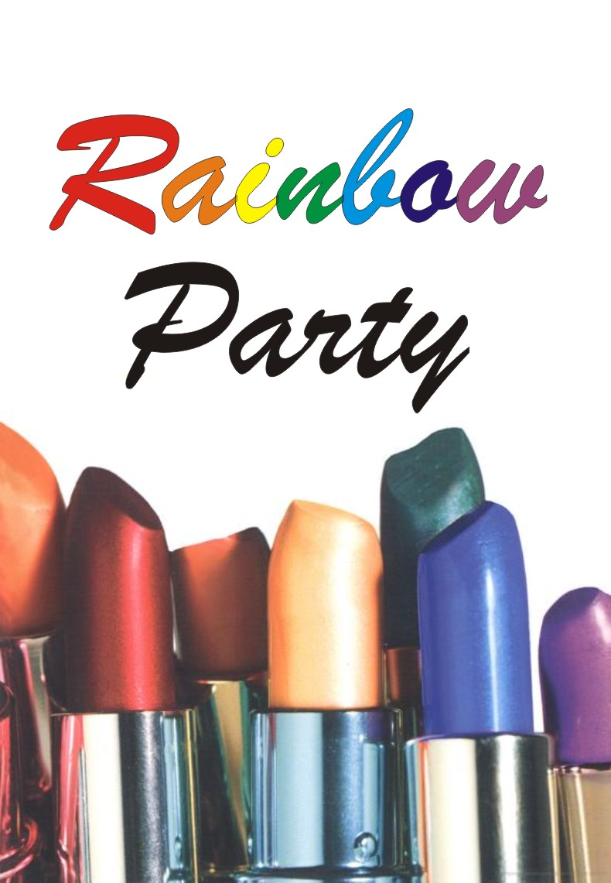

ЗА ПРОДОЛЖЕНИЕМ ОБРАЩАЙТЕСЬ ПО АДРЕСУ: isp-m@narod.ru
Укажите, какой вариант (русский или английский) вы хотите получить.
Стоимость и в том, и в другом случае составит 300 руб.

«Радужная вечеринка» - скандально известная повесть Поля Радитиса, вызвавшая бурю самых разных эмоций после публикации, в том числе - критики и негодования со стороны целомудренно настроенной публики в Нью-Йорке. В ней рассказывается о подростках, устраивающих секс-развлечения, одной из разновидностей которых и была так называемая «радужная вечеринка», в процессе каковой одному или нескольким молодым людям последовательно делали минет девушки с губной помадой разных цветов, оставляя таким образом «радугу» цветных следов на их половых членах..

Кроме собственно секса, в радужных вечеринках присутствовал так же элемент состязания — какая из девушек оставит следы ближе всего к основанию члена (что говорит об уровне владения техникой орального секса), и какой из молодых людей сможет составить на своём половом члене наиболее «полную» радугу (что говорит о сексуальном темпераменте молодого человека, который сможет дойти до конца и удовлетворить всех девушек).

Книга была рекомендована издателем для возрастов от 16 лет и старше на том основании, что она является своего рода предупреждением для читателей об опасностях орального секса (автор даже нарочно включил в книгу эпизод, где многие участники такой вечеринки последовательно заражаются неприятным венерическим заболеванием)

Однако книга вызвала противоречивый отклик. Экспертами указывалось, что подобная популяризация (пусть даже и в негативном контексте) вполне может пробудить у подростков любопытство к описанной разновидности сексуальных отношений и желание попробовать, то есть результат прочтения книги вполне может оказаться обратным предполагаемому. В результате чего книга подвергалась многочисленным запретам и изъятиям из книжных магазинов.

В настоящий момент книга запрещена во многих странах и является библиографической редкостью, а в многочисленных энциклопедиях и исследовательских материалах старательно доказывается, что события книги являются вымыслом, и на самом деле «радужные вечеринки» никогда не существовали в реальности.

Впрочем, это вызывает лишь смех у тех, кто сам неоднократно присутствовал на таких вечеринках и принимал в них участие.

RAINBOW PARTY. PAUL RUDITIS

1.01

Gin took the slender shaft on the tube in her palm. She gave a gentle tug along the base and watched as the lipstick extended to its full length. Her eyes darted to the sides, making sure no one was watching as she tilted the ruby red tip to her lips.

“Gin, that’s disgusting!” Sandy shrieked as she came around the row of lipstick displays.

Busted.

Gin quickly pulled the red lipstick away from her mouth before she had a chance to test it.

“It’s not like they have tasted here”, Gin hissed, shooting a look at the saleslady. The woman was staring at them, probably because of Sandy’s outburst.

She wouldn’t be having this problem if they were shopping at ULTA or Sephora instead of a tacky kid’s store like Pizzazz! This was the only place Gin could afford to buy the half dozen lipsticks she needed for the “party”. The store’s Teen Taboo line had a perfect selection of colors. It was convenience that hard brought her there.

“I can’t believe you were just going to try on that lipstick”, - Sandy said. – “Someone else might buy that.”

“How else am I supposed to know if I’m a?” – Gin checked the name of the color – “Harlot?”

“The obvious joke was just waiting to be made, but Gin knew Sandy wouldn't go there.
"1 think you're more a Candy Apple ." Sandy suggested, proving the point. She held up a painfully bright color that was more suited to sports cars than body parts.

“Who gives a fuck?" Gin grabbed the lipstick from Sandy and dropped it into her yellow basket. “You can be boring red. I want something with a little more ..."

“Pizzazz?" - Sandy asked.

“Yes. That's exactly what I was going to say, Sandra Dee",- Gin said.

“What?" - Sandy asked. - “What did I say?"

“Never mind" - Gin replied. Sometimes Sandy could be so juvenile.

They were almost at the end of sophomore year. Pretty soon they'd officially be juniors ... upperclassmen... upperclasswomen.

Then again. Gin's plan for the afternoon called for Sandy to become a woman just a little sooner.

“I want something wild." Gin said, grabbing another tube. “Like Electric Orange."

“Or Ginger!" - Sandy said, holding a washed-out lipstick that looked more like a sunless tan gone wrong. - "You know like……"
“Don't say it." Gin warned. “Ginger" was what her parents called her. She had given it up when she entered high school last year. But her parents just refused to let go.

At least they stopped calling me Ginny.

Gin dropped the Electric Orange into her basket and left the Ginger tube on the clearance table beside them. No one was going to pay full price for it. anyway.

“Check this out." - Sandy said with a giggle as she held up a purple lipstick. "Jammin'Jam. Who would wear that on their lips?"

“Perry?" - Gin suggested.

"Why would Perry ... oh ... I get it." - Sandy wasn't laughing. "Is he really coming to the party?”

“That's what Hunter said." - Gin blew off the question. “I'll believe it when I see it." “Doesn't seem like his kind of thing."

"No ... not exactly." - Gin said with a smile.

“Then why did you invite him?"

“Hell if I know."- Gin said. - "Hunter wanted me to."

“And you can't say NO to Hunter."

“Oh. I can say NO. I just haven't found a reason to yet."- Gin held out another purple lipstick. - “How about Plum? The name's not exciting, but it's a decent shade."

Sandy examined the color. “That would look good on Rose." - she said thoughtfully.

“Yeah ... whatever." - Gin dropped the lipstick in her basket.

“If you hate her so much, why did you ask her to come?

“How else was I going to get Ash there?" - Gin replied. -“Besides, I don't hate her."

“You don't like her either." - Sandy reminded her friend.

Honestly, Gin just had no patience for the female half of Harding High's cutest couple of the sophomore class. Rose and Ash were the kind of sic keningly cute couple that made Gin want to puke. Especially when they acted all weird, doing things they thought were hilarious, but were just stupid, as far as she was concerned. Gin didn't know why Rose embarrassed herself in public like that.

“Let's just say ... I wanted to see if I could add a little spice to their relationship." Gin smirked. And by «spice» she meant conflict. Gin not-so-secretly hoped that the end of the party would also be the end of the cutest couple.

Bitter? Yes. But Gin was okay with that.

“You invited Jade, too." - Sandy said. - “And I know, you hate her"

“Hate - is such a strong word", - Gin said.

Gin was smart enough to know - if she had limited the party to just her girlfriends, it would be a very small one: Namely, her and Sandy. It's not that the girls at school didn't like Gin. It was more like they tolerated her. Not that Gin wasted any energy trying to be friends.

She was much more popular with the boys. Which is the way Gin wanted it.

Sandy was the only girl, who actually hung out with Gin regularly. Followed her was more like it. But Sandy was the kind of girl Gin's parents wanted to see her hanging with. And Gin liked to keep up appearances, especially where her parents were concerned. Sandy was a very good cover.

“I can't believe we're doing this." Sandy said, shaking her head.

“Shopping?" Gin asked, like she didn't know what Sandy was talking about.

This Rainbow Party thing had seemed like a good idea when Gin first heard of it. Well, actually it sounded like a gay political group, but once she found out what it really was, her interest level shot up a thousand percent. But now, with only two hours until party time, she was actually starting to get nervous too. Normally. Gin didn't “do" nervous. It was such a waste of emotion.
But so many questions kept popping up in her head.

What if no one comes?
Will I really be able to keep it a secret until it's over?
If the girl/boy ratio is uneven, how will I balance out the equation?

That last question had come to her during algebra. Instead of wondering what would happen when two trains traveling at different speeds met (most likely death and destruction, if on the same track), all Gin could think about was what would happen if six boys showed up, but she and Sandy were the only girls. Aside from the damage it would do to her reputation, it would wreak havoc with all the devious plans she had for the party.

“Okay, we've got red, orange, and purple." - Gin said. - “Now we just need yellow, green, and blue."

“Don't forget indigo." - Sandy said as she scanned the rows of lipstick tubes.

“What are you talking about?"

“Indigo."- Sandy repeated as if that explained everything. - “You know: red, orange, yellow, green, blue, indigo, violet."

"That's seven lipsticks. Only six girls are coming. We don't need it."

"What if someone crashes? Or brings a friend?" - Sandy asked the innocent question that was haunting Gin.

'That won't happen." - she said, as if saying it out loud made it true. Gin didn't know what she would do if anyone unexpected showed up. Every person on the guest list was chosen for a specific reason. There was no room for surprises.
"It doesn't hurt to be prepared." - Sandy pulled a tube out of the display.

"Thanks for the Girl Scout lesson."

"Actually, that's Boy Scouts. The Girl Scouts!"

"Fine. Add it to the pile, just in case. But you're paying for it." - Gin held out her basket, and Sandy dropped the extra one inside.

Gin focused on the colors she knew they would need, comparing Key Lime with Olive U. She put them both back, settling on the aptly named Envy.

"I wonder if Jade will come", - she thought.

"Check this out!" - Sandy squealed, showing off a bright yellow lipstick. "It's called Banana. Get it?”

Yeah. She got it.

Gin grabbed the tube and put it with the others. Banana, Electric Orange, Plum ... it was beginning to look like a grocery store. On the bright side ... five down, one to go ... and a spare just in case someone unexpected shows up.

If Subset A is greater than Subset B, then ...

"We need to find a blue that really stands out",- Gin said, checking out the rows. "Something like ... Sapphire?"- She yanked the lipstick off the display and tore off the lid. The color was bold but not overly so, with a touch of a shimmer effect.

Perfect!

"I love it." - Sandy said with just the right amount of awe in her voice. It was as if Gin had shown her the Holy Grail as opposed to a mixture of synthetic dyes pressed into an obscenely phallic shape.

On the way to the register, Gin threw a tube of Harlot in with the others. The bright red lipstick was for her personal collection. She deserved a treat for pulling this whole thing together.

Gin dropped her little basket on the counter. She wondered if the saleslady had any idea what she'd be using those colors for. Girls probably didn't go around purchasing a rainbow selection of makeup at Pizzazz! every day.

Or maybe they did.

The weird part was that Gin kind of wanted the woman to suspect that something was going on. The best part of being up to no good is when people know you're up to no good, but can't do a thing about it.

"Have a nice day!" - the saleslady said as she handed Gin a small plastic bag with a big PIZZAZZ! logo emblazoned on the side.

This party is going to be off the hook she thought. As long as everyone shows up.
"Should we hit the party store?" - Sandy suggested. - "I think a few balloons and some streamers would really look great in your living room".

Gin stopped suddenly, forcing a mother pushing a stroller to swerve to the left to avoid hitting her. - "You've got to be kidding."

"What?" - Sandy said as she stopped too. - "Decorations… "

"This isn't a balloons-and-streamers kind of event." - Gin said sharply.

Sandy didn't think it was a bad idea. If you're going to have a theme party, it makes perfect sense to decorate that way. That's what she did when she had the Hello Kitty party for her last birthday.
Too bad it didn't work out the way she had hoped.

In hindsight, Hello Kitty wasn't a great theme for her first coed party. She didn't realize how much fun the boys would have with it... and not in a good way. They started by putting her dolls in obscene poses and went from there.

But the girls had been much worse.

They all treated Sandy like a pariah for having picked such a childish theme. The worst part was that they didn't even have the nerve to say anything to her face. They just all talked about it in loud whispers.

Boys always got a bad rap for being mean and cruel because they were so obvious about it. But nothing could match the vicious power of a girl armed with condescension and sarcasm.

Just because Gin's Rainbow Party was a different kind of party, Sandy thought, didn't mean they couldn't have some fun. It was called a Rainbow Party, after all. It was like the easiest theme to decorate around.

"Why can't it be a balloons-and-streamers kind of party?" - Sandy asked. "I mean, first you didn't like my idea about the invitations..."

"Are you still on that?"

“It's a good idea."

“It sucked. What exactly did you want us to put on the invites?" - Gin asked.

"You know... the usual stuff," - Sandy replied. - "The time... directions to your house... maybe draw some rainbows or some ... oh..." - Sandy’s mental picture of the invitations wasn't exactly the kind of thing she wanted her mother to accidentally find. - "I know... I know... 'Sandra Dee’"

"Exactly."

Sandy was getting tired of that "Sandra Dee" nickname Gin had given her. It came from Grease, and Rizzo's song about Olivia Newton-John's character, Sandy, in the movie. To Gin it was the worst possible insult. She considered immaturity the ultimate sin. And when it came to guys, Sandy's maturity was at about fourth-grade level.

Gin's stories always sounded so exciting. The things she did, were almost so unbelievable, that Sandy couldn't help getting caught up in them. When Gin would describe what it was like being with a boy, Sandy couldn't help but get a vicarious thrill from it. At the same time, Sandy hated to listen because all she could think about what how far she had never gone with anyone.

When Sandy stopped to think about the reality... the actual things that Gin did... she was almost disgusted by her. Sandy wasn't so sure that she'd ever want to be like that. She was really not sure she'd be ready for it by three o'clock that afternoon.

When Gin first told her she was going to throw a party, a Rainbow Party. Sandy's mind was full of Care Bears and Strawberry Shortcake. She knew it sounded odd, since Gin rarely liked childish things like that—even for their retro appeal. But Care Bears and Strawberry Shortcake stuff were sold at Hot Topic right next to Good Charlotte, Metallica and Iron Maiden. Sandy assumed that rainbows from the 70s were the new "in" thing.

She was only partially right.

When Gin explained what a Rainbow Party was, Sandy had assumed she had heard wrong. She knew that Gin was... experienced... but this was something else. This was just plain dirty.

Sandy wasn't experienced in the least. She had never even kissed a boy. Well, except for Johnny Carter. But they were both six years old at the time and he had pushed her in the mud afterward, so that didn't really count. That one kiss was nothing like the deep romantic kisses she had dreamed of having. Those dreams never included... well... what Gin was planning. And now she was helping Gin prepare for it.

ЗА ПРОДОЛЖЕНИЕМ ОБРАЩАЙТЕСЬ ПО АДРЕСУ: isp-m@narod.ru
Укажите, какой вариант (русский или английский) вы хотите получить.
Стоимость и в том, и в другом случае составит 300 руб.

ЗА ПРОДОЛЖЕНИЕМ ОБРАЩАЙТЕСЬ ПО АДРЕСУ: isp-m@narod.ru
Укажите, какой вариант (русский или английский) вы хотите получить.
Стоимость и в том, и в другом случае составит 300 руб.

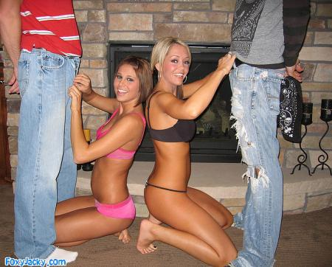

ЗА ПРОДОЛЖЕНИЕМ ОБРАЩАЙТЕСЬ ПО АДРЕСУ: isp-m@narod.ru
Укажите, какой вариант (русский или английский) вы хотите получить.
Стоимость и в том, и в другом случае составит 300 руб.

